TASK 3
Real-World Dataset Analysis Project
Exploring, cleaning and interpreting the Titanic passenger dataset
Data Science Internship Report
Submitted by: [Your Full Name]
November 2026

1. Dataset and context
For this project I chose the Titanic passenger dataset from the seaborn-data repository (originally compiled from historical passenger records). I picked it for three reasons: it comes from a reliable, widely used public source; it has a clear analytical question (who survived, and what separated them from those who did not); and it contains exactly the kinds of problems a real dataset has, namely missing values, duplicated rows, skewed variables and outliers.
The raw file has 891 passengers and 15 columns. The target I focused on is survived (1 = survived, 0 = did not). The other variables describe passenger class, sex, age, family aboard (sibsp for siblings or spouses, parch for parents or children), fare paid, port of embarkation and cabin deck.

Objectives
- Understand which passenger characteristics are associated with survival.
- Prepare the data properly, and document every cleaning decision.
- Present findings that a non-technical reader could follow, with honest limitations.

2. Exploring the raw data
Check | Finding
Shape | 891 rows × 15 columns
Missing: age | 177 values (19.9%)
Missing: deck | 688 values (77.2%)
Missing: embarked / embark_town | 2 values each (0.2%)
Duplicate rows | 107 fully identical rows
Overall survival (raw) | 38.4%
Fare skewness | 4.57

The most serious gap is the deck column, which is missing for more than three quarters of passengers, so it is not usable as a normal feature. Age is missing for about one in five passengers, which is too many to simply ignore. The two missing embarkation values are trivial.

3. Cleaning and preprocessing

3.1 Decisions and reasoning
Problem | What I did | Why
Missing age (177) | Filled with the median age of the passenger’s class and sex group; added an age_missing flag | A single overall median would erase real differences between groups; the flag lets me check the imputation did not drive results
Missing embarked (2) | Filled with the most common port (Southampton) | Only two rows, so the effect is negligible
Missing deck (688) | Dropped the column, kept a has_cabin_info flag | Too sparse to impute, but whether a cabin was recorded may itself be informative
Duplicates (107) | Removed, leaving 784 rows | See the caveat below
Wrong / wasteful types | Converted sex, embarked, embark_town to category; survived to int8 | Saves memory and makes intent clear
Redundant columns | Dropped alive, class, who, adult_male | They repeat information already in survived, pclass, sex, age
Skewed fare | Added log_fare | Skewness fell from 4.57 to 0.42

A caveat on duplicates. The dataset has no passenger ID, so identical rows are not necessarily the same person. Groups of passengers who bought tickets together (families, for instance) can legitimately share the same class, fare, port and family size. I removed them to follow standard practice, but the safer reading is that some of the 107 could be genuine passengers. For that reason I treat the exact percentages below as indicative rather than precise, and I would want to test whether conclusions change if the rows are kept.

3.2 Outliers
Using the 1.5 × IQR rule, 102 fares sit above $73.2 and 15 ages sit above 62. I did not delete them. The high fares are real first-class tickets, and the older passengers are real people, so removing them would distort the story instead of cleaning it. For fare I used the log transformation to reduce the influence of the extremes when comparing groups.
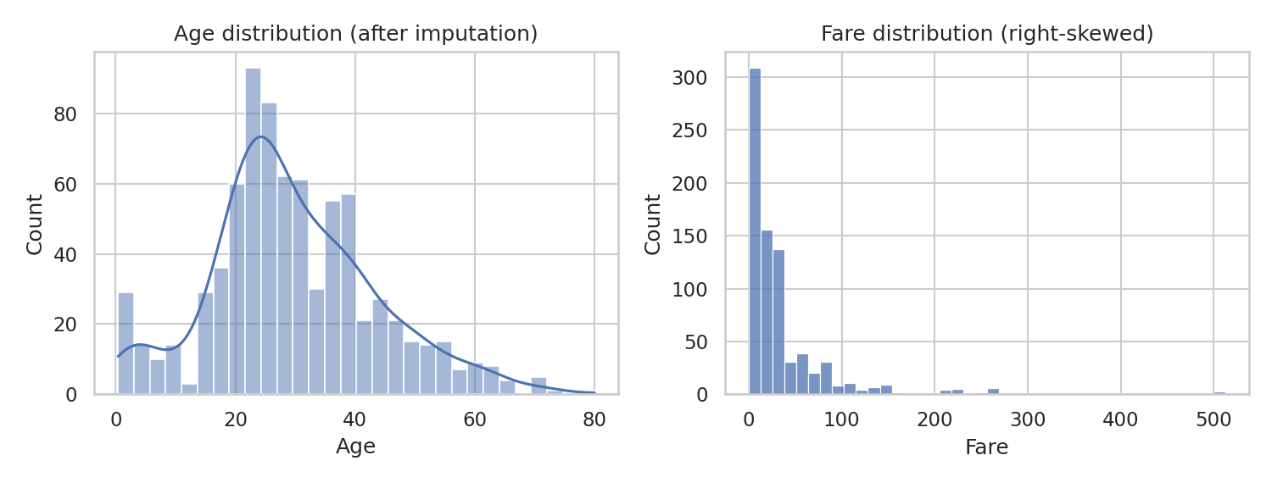
Figure 1. Age and fare distributions after cleaning. Fare is strongly right-skewed.
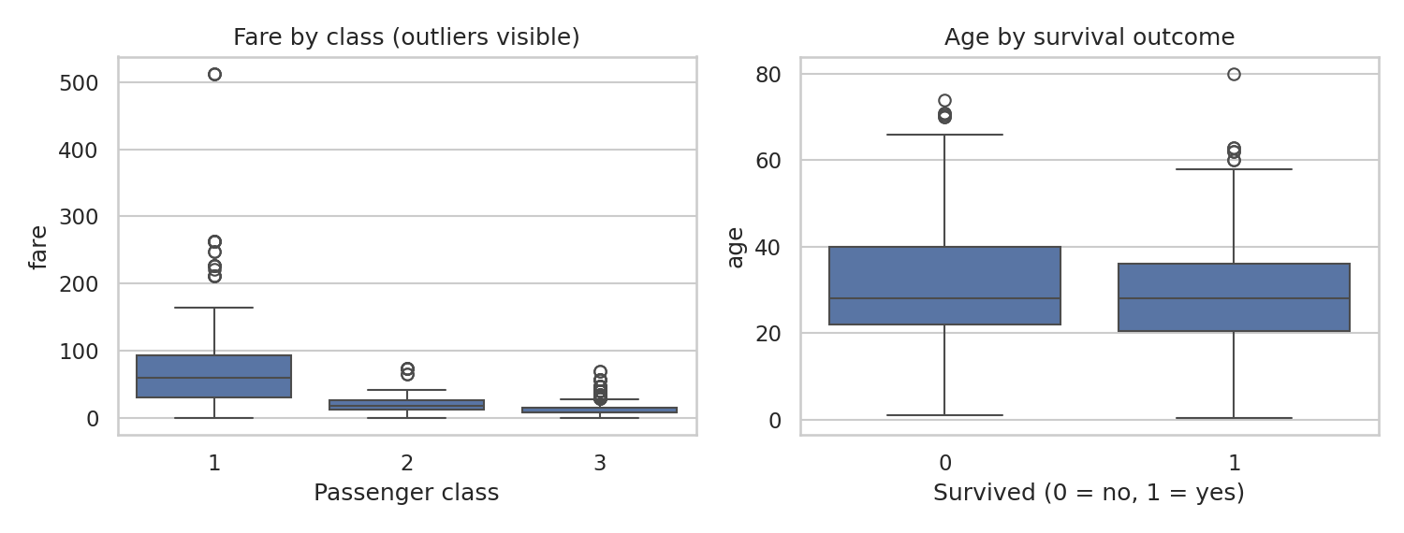
Figure 2. Fare by class and age by outcome. The high first-class fares are genuine, not errors.
After cleaning there are 784 rows and 0 missing values.

4. Exploratory data analysis

4.1 Sex and class
The biggest differences in the whole dataset are by sex and class. Women survived at 74.1% versus 21.6% for men. By class, survival was 63.1% in first, 50.9% in second and 25.7% in third class.
Combining the two is where it gets interesting. Among women, survival was 96.8% in first class and 91.8% in second class, but only 47.2% in third. Among men, it was 37.2% in first, 18.5% in second and 15.8% in third. Being female helped in every class, but being in third class cut a woman’s chances roughly in half, while for men the class gradient was much weaker after the first-class jump.
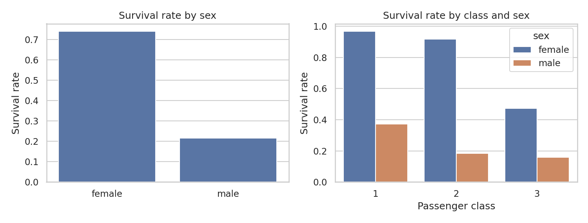
Figure 3. Survival rate by sex, and by class split by sex.

4.2 Age and family
Age group | Survival rate
Child | 57.4%
Teen | 44.8%
Young adult | 40.2%
Adult | 38.7%
Senior | 22.7%

Children had the best odds (57.4%) and seniors the worst (22.7%), consistent with the "women and children first" pattern. Family size showed a non-linear effect: passengers travelling alone survived at 33.6%, small families of 2 to 4 at 57.6%, and large families of 5 or more at only 18.2%. A straight-line correlation would have missed this entirely (the correlation between family size and survival is just 0.015), which is a good reminder to group and plot instead of relying on a single coefficient.
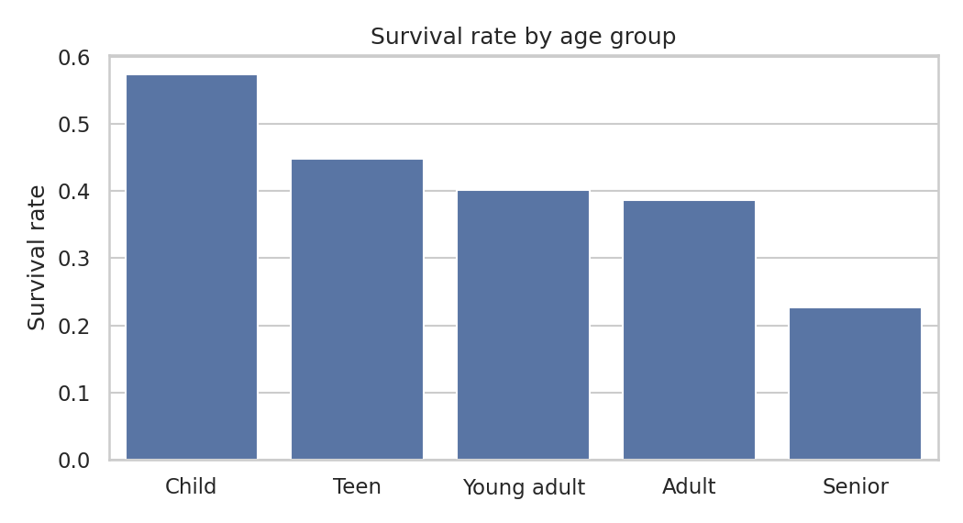
Figure 4. Survival rate by age group.

4.3 Port of embarkation and fare
Passengers who boarded at Cherbourg survived at 58.1%, compared with 37.4% at Southampton and 33.9% at Queenstown. I suspect this reflects a different mix of classes at each port instead of anything about the port itself, but I did not test that formally, so it stays a hypothesis. Median fares were $60.29 (first), $18.75 (second) and $8.05 (third).

4.4 Correlations and significance tests
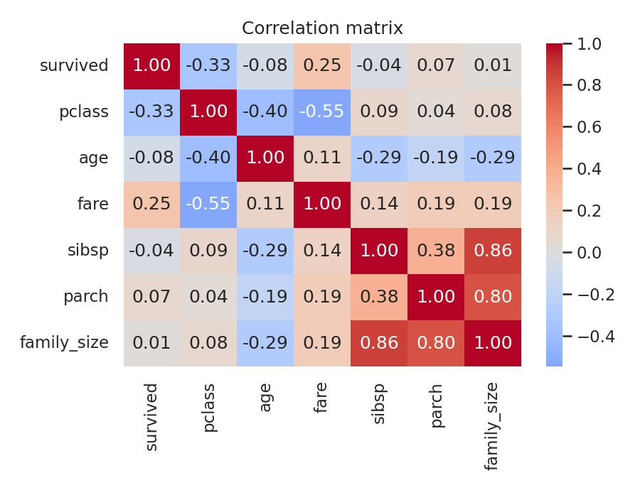
Figure 5. Correlation matrix of numeric variables.
Passenger class has the strongest correlation with survival (-0.333), followed by fare (0.247); the negative sign for class simply means that a lower class number (first class) goes with higher survival. Age is only weakly correlated on its own (-0.075).
- A chi-square test of sex against survival gave χ² = 206.4 with a p-value far below 0.001, so the sex difference is very unlikely to be chance.
- A Welch t-test on fares of survivors versus non-survivors gave t = 6.39 and p < 0.001, so survivors paid significantly more on average.

5. Key findings
- Sex was the strongest single factor. Women survived at roughly three and a half times the rate of men.
- Class mattered a lot, especially for women, where third-class passengers fared far worse than first and second.
- Children did best, seniors worst, matching the evacuation priorities described in historical accounts.
- Family size had a curved effect: small groups did best, lone travellers and very large families did worse.
- Wealth and survival moved together, but fare, class and cabin records are all linked, so I cannot say which one mattered most.

6. Limitations and recommendations
- This is observational historical data about one event. These are associations, not proof of cause.
- Missing ages were imputed, and the duplicate-row question described above could affect exact percentages.
- Survival was shaped by factors the data does not contain, such as cabin location and proximity to lifeboats.
- Next steps: build a classification model (logistic regression or a random forest) with cross-validation, test whether results hold when duplicates are kept, and look at interactions such as class × sex more formally.

7. Conclusion
The project followed the full analysis workflow: pick a reliable dataset, inspect it, clean it with documented reasoning, explore it with statistics and charts, and interpret the findings with their limits in mind. The data tells a clear story about how sex, class and age shaped survival, and it also shows why careful cleaning decisions matter, since a few judgement calls, like handling duplicates, can shift the numbers. The full code is in the GitHub repository (scripts/task3_titanic_eda.py) and the cleaned dataset is saved as data/titanic_clean.csv.

